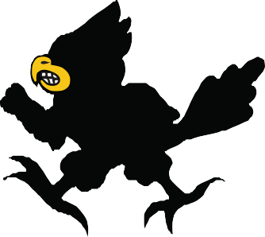
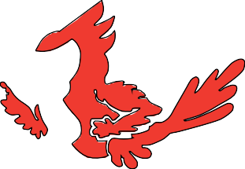
Chippewa Falls Middle School
Classroom Expectations

Be Safe

Be Respectful

Be Responsible

Be Productive

